Soil temperature logger set up
June 11, 2017, 0900
P. Bierman

Below is a short set of notes detailing the installation of two sets of soil temperature probes in anticipation of modelling over-summer snow storage. Two monitoring sites were selected based on the ease of snowmaking and snow transport as well as partial shading during summer months.

The sites were selected ahead of time by D. Dreissigacker who pounded a metal rod into the soil to a depth of about a meter. The holes remained open and were marked with stakes and flagging.

The Hobo loggers were set up and tested in Burlington by P. Bierman. The loggers were encased in snap closure plastic boxes, drilled out so that the cables passed through; they were duct taped for strain relief. The cables were marked with silver ink every 10 cm and labeled by relative depth. Depth measurements were made to the center of the sensor which is several cm long. The logging interval was set at 20 minutes. Loggers can be read out over Bluetooth from nearby trails (Lemon’s Haunt) without having to visit the monitoring site.

One site, termed CHIP, is adjacent to the activity center, in the woods, between the training hill and chip hill and is mostly shaded under open tree canopy. The second site, termed POND, is located below the Lemons Haunt trail in an area previously cleared to be a pond side. It is fully shaded and densely vegetated.

We buried the lowest sensor at the bottom of the hole and then backfilled with soil, packing with the metal rod. Sensor depths are as follows:

Site CHIP, logger numbers 544 and 543  1 m – sensor B, 543  50 cm – sensor II, 543  20 cm – sensor III, 544  5 cm – sensor T, 544 | 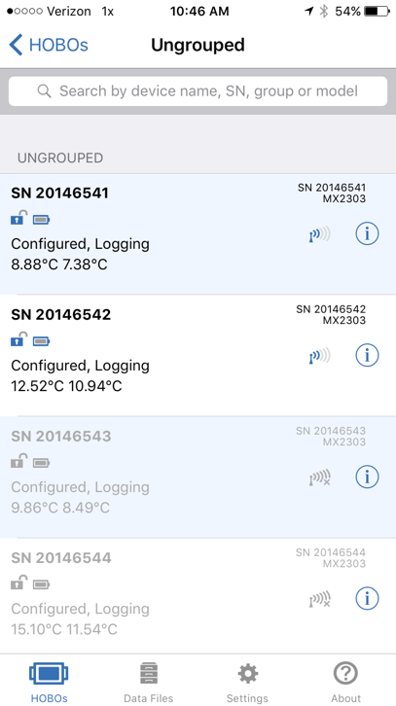
Site POND, logger numbers 542 and 541
1.05 m – sensor B, 541
50 cm – sensor II, 541
20 cm – sensor III, 542
5 cm – sensor T, 542

An hour after installation, the sensors had equilibrated with ambient soil temperature showing the expected decline with depth given the warm (+25C) air temperature and windy day. The well shaded POND site is colder than the more open CHIP site.

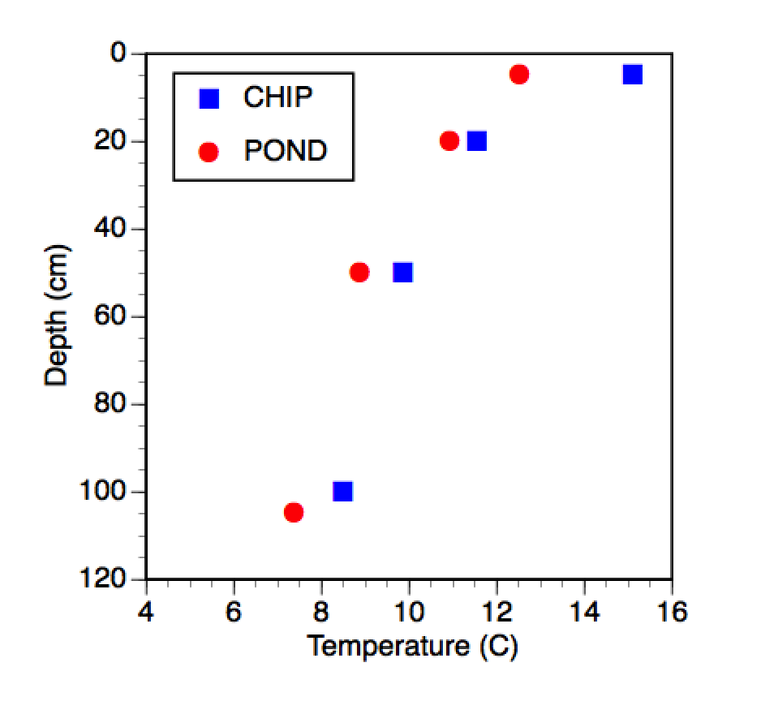 | 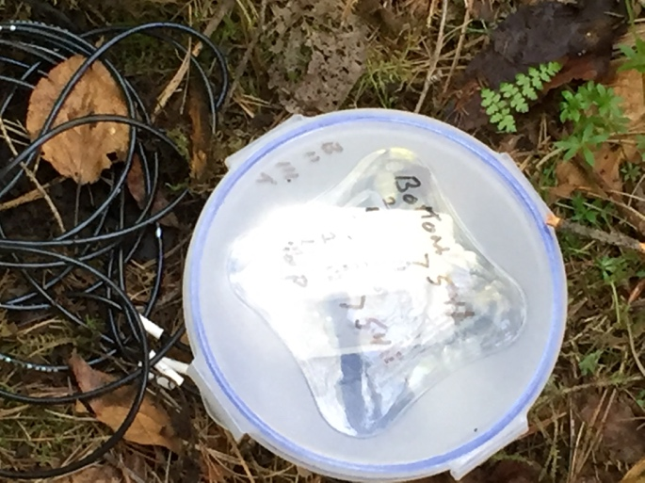
Temperature profiles, 1030, June 11 | Logger enclosure
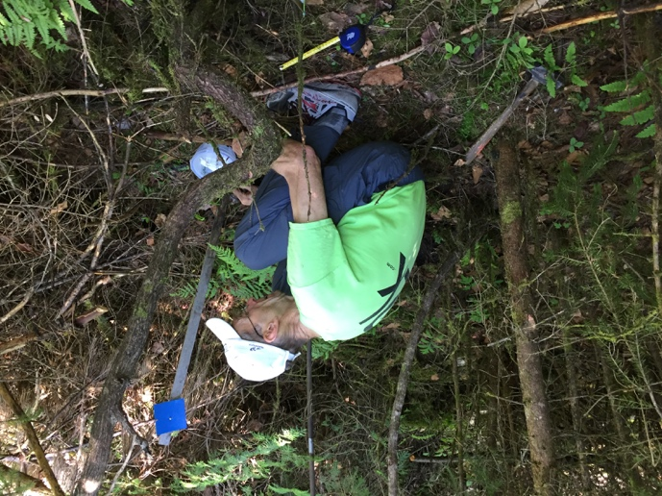 | 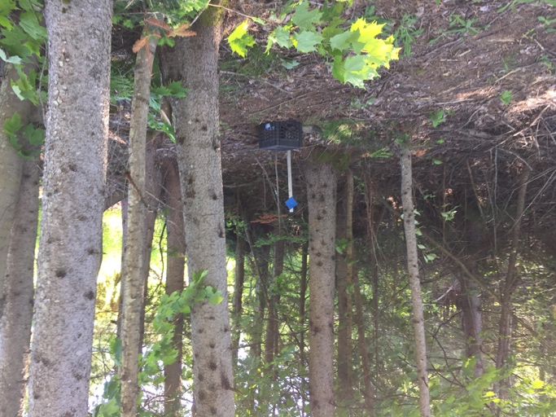
POND Site | CHIP site

